🧠 Use Case Description
This use case focuses on analyzing e-commerce data to understand customer behavior, transaction patterns, and sales trends. The goal is to optimize operations and boost revenue.

📊 Key Analyses
- Inactive Products
- Filter for inactive products and export the list to Excel.
- Inactive Users
- Filter for inactive users, provide the list in Excel.
- Purchases by Users
  - Entire list of active products purchased by users across the years.
- Revenue Analysis
  - Visualize order volume over time and compare regional contributions to total sales.
- Product Performance
- Identify the best-selling products overall and by country.
- User Behavior
  - Understand how often users place orders and compare user base across geographic areas

📂 1. Data Access & Preparation
Files Needed:
- Orders_Data.xlsx
- Order_Products_Data.xlsx
- Products_Category.csv
- Products_Data.xlsx
- User_Data.xlsx

- Use the Excel Reader node to import data from Orders_Data.xlsx and Order_Products_Data.xlsx.
- Use the CSV Reader node to load Products_Category.csv, and the Excel Reader node to load Products_Data.xlsx.
- Use the Excel Reader node to import data from User_Data.xlsx.

🧹 2. Data Cleansing & Transformation
a.
    - Column Filter: remove the created_at, total_price, and updated_at columns from the Order_Products_Data table.
    - Joiner: combine Orders_Data and Order_Products_Data (above output) based on the order_id field.

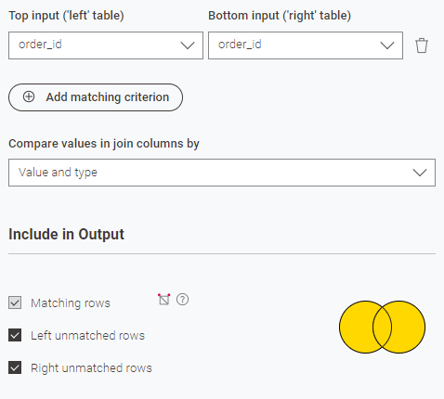

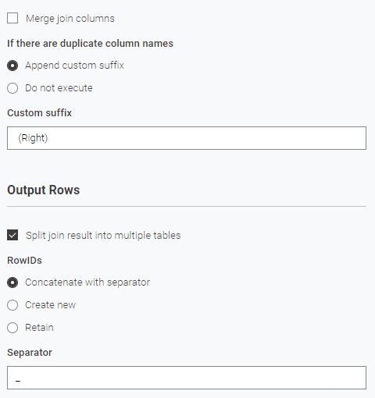

    - Concatenate: union the results of the join tool - join result and left unmatched rows.
    - Column Filter: exclude created_at, updated_at and order_id (right) from the resulting dataset.

    - Column Renamer: standardize column names in the Products_Category table.
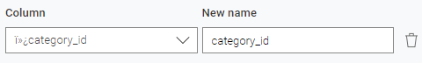
    - Column Renamer: update column names in the Products_Data table.
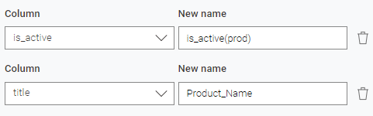
    - Joiner: merge output of i & ii using the category_id field.
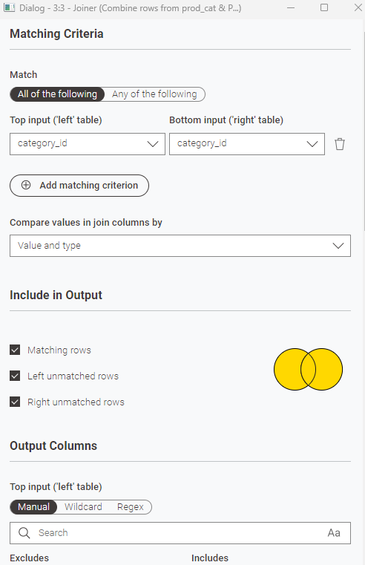
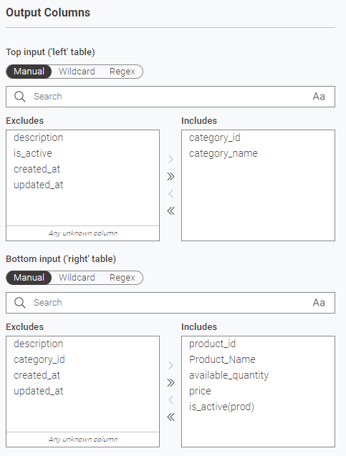
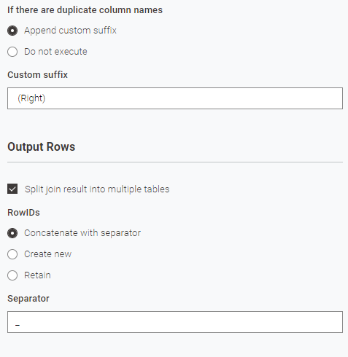
    - Column Filter: remove price from the join result.

    - Value Lookup:
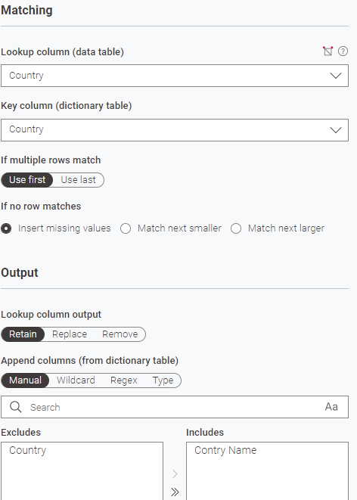

    - Column Renamer:
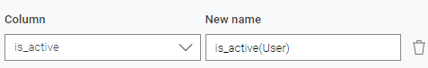
    - Column Combiner:
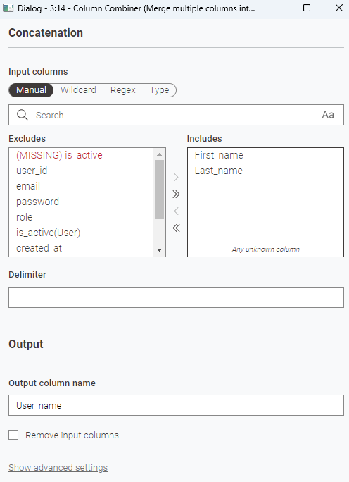
    - Column Filter: exclude first_name, last_name, created_at and updated_at.

🔀 3. Data Join Operations
    - First, join the outputs from steps 2.a.iv and 2.b.iv using product_id as the key.
    - Next, join the result from step 3.i with the output from step 2.c.iv using user_id as the key
🔎 4. Filtering, Sorting & Sampling
- Column Resorter: ordering of the input columns.
- Sorter: Sort the data by user_id in ascending order.
- Row Splitter:
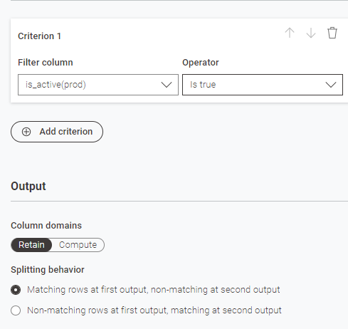

- Row Splitter: use included rows of output iii.
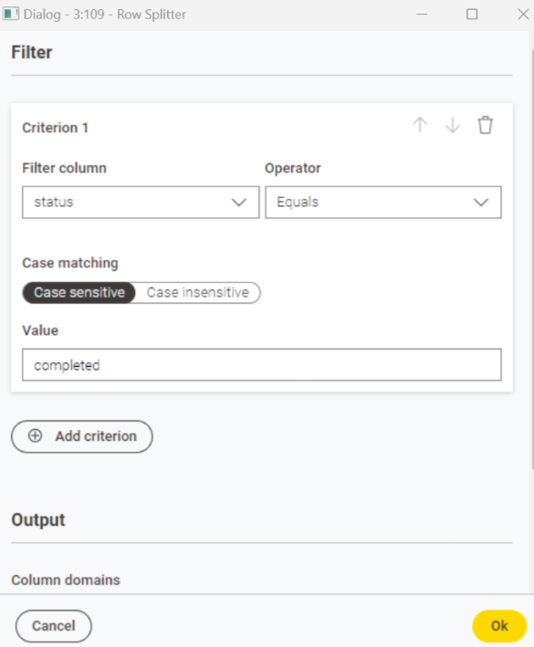

- String to Date&Time: use the included rows output of iv. Convert order_date to date time format.

- Date&Time Part Extractor:
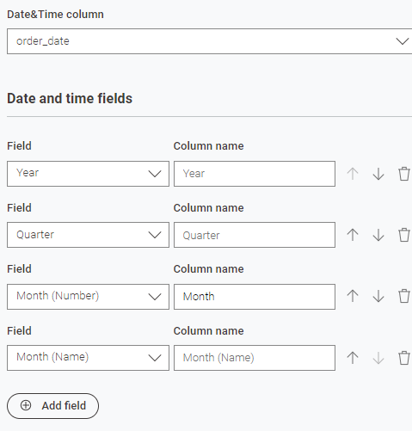

📈 5. Data Analysis & Insights

Inactive Products
- Excel Writer: write the excluded rows output of 4.iii to excel.

Inactive Users
- Row Splitter: use the output of 4.ii as input. Filter using the column is_active(user).
- Excel Writer: write the rows to excel.

Purchases by Users
- Excel Writer: output results from 4.vi.

Revenue Analysis

- Date&Time Configuration: outputs a variable with a fixed date time.
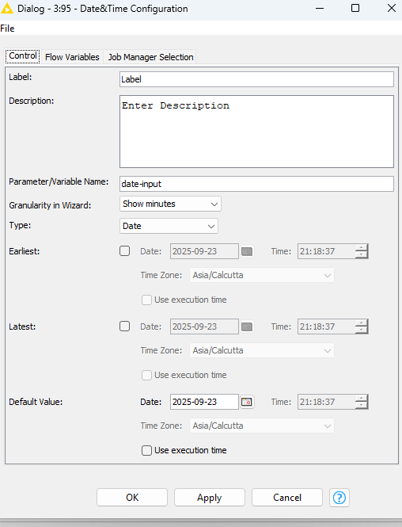

- String Manipulation (Variable):
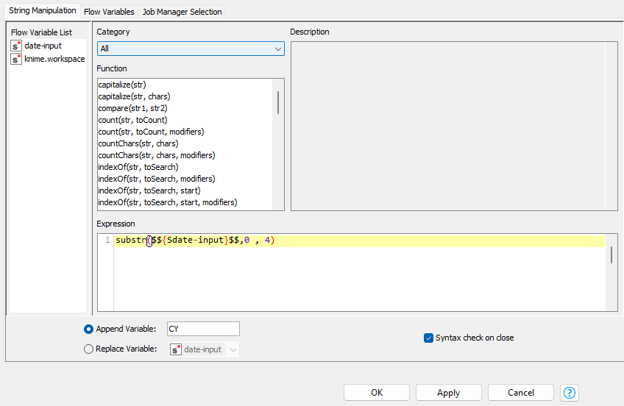

- Variable to Table Row:
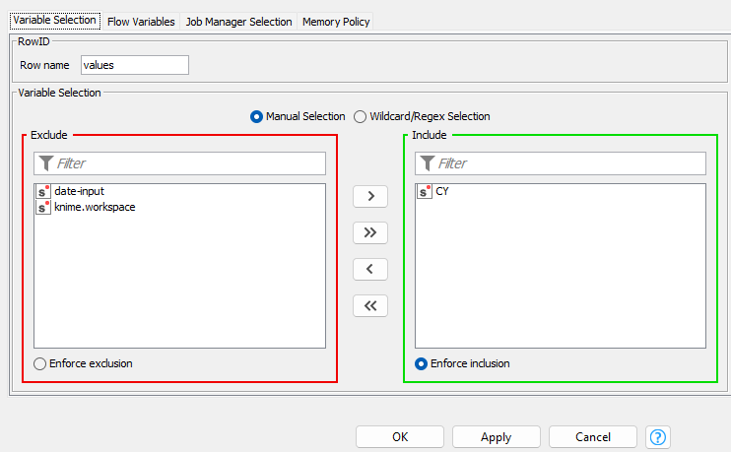

- String Manipulation
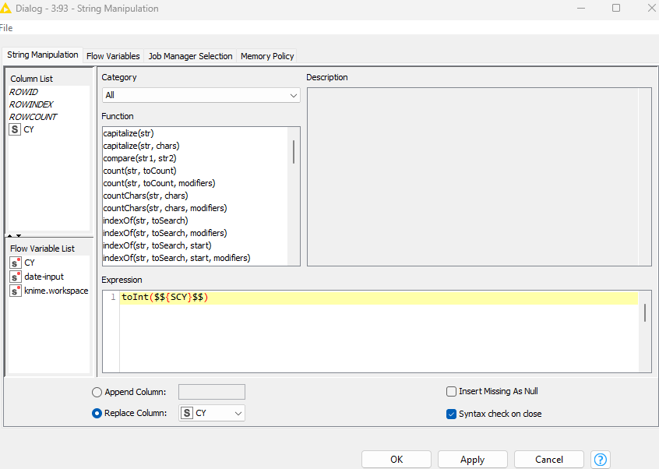

- Math Formula:
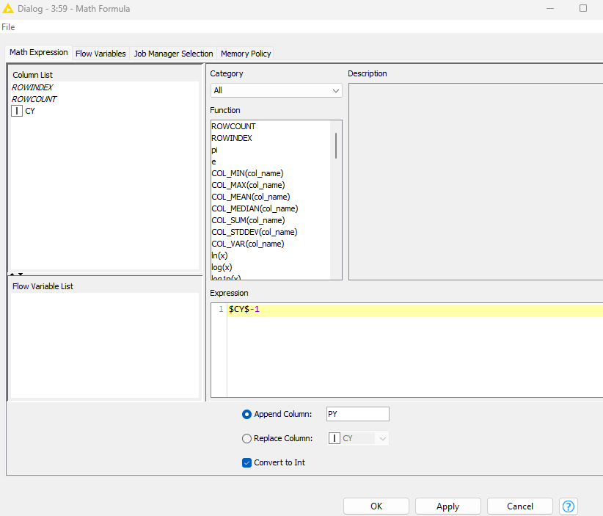

- Table Transposer:
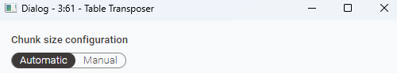

- Joiner: join existing data with the output from 4.vi on the Year.
- GroupBy: by the year on the join result.
- Column Renamer:
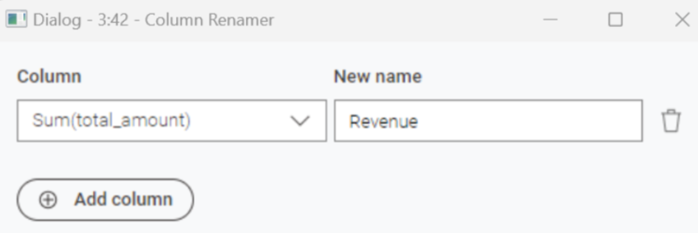
- Number to String: converts from number to string
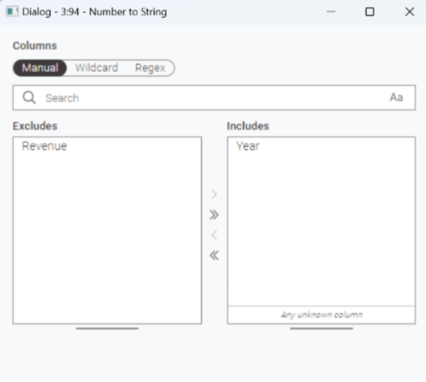

- GroupBy: use output of 4.v as input and groupby country.

- RowFilter: use output of 4.vi as input and include only records of 2025.
- GroupBy: Month and Month(name)
- Column Renamer:
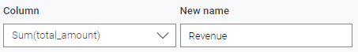
- Use the outputs of a,b & c streams created above as input and generate charts.
Product Performance

- GroupBy: Use the output of 4.v as input. Perform grouping by product_id and product_name.
- Top k Row Filter:
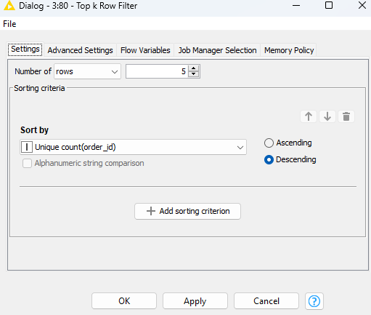
- Sorter: sort by Unique count(order_id) in descending order
- Column Renamer:
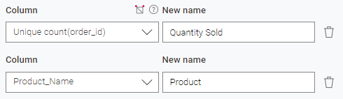

- GroupBy: Use the output of 4.v as input. Perform grouping by product_id, product_name and country.

- Joiner: merge the output of a&b streams on product_id.
- Sorter: Quantity sold in descending order on join result.
- Use output of a&c streams and generate charts.

User Behavior

- GroupBy: use 4.v as input and group by order_id.
- Column Renamer:
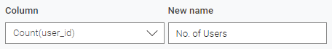

- GroupBy: use 4.v as input and group by country.
- Use outputs of a&b streams and generate charts.

**********************

